Hardware & Software

Part 1: Hardware

Step 1: Hardware Identification
For the following image, identify the part, provide a brief explanation in your own words what its function is.

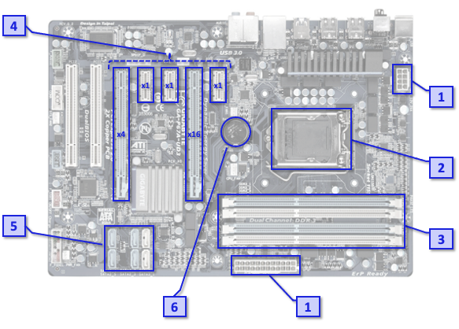
# | Name | Function
1
2
3
4
5
6

Step 2: Understanding Hardware Properties

Activity: Diagnosing Hardware Issues
In this activity, you’ll take on the role of IT technicians tasked with diagnosing and resolving hardware issues in real-world scenarios. Work collaboratively in your groups to identify the problem, suggest solutions, and explain your reasoning.

Step 1: Form Groups
• Form groups of 3-4 students. Each group will act as a team of IT technicians.

Step 2: Review the Scenarios
Your group will be assigned one of the following scenarios:

Scenario 1: Slow Computer Performance
• A user reports their computer has become slow over time, with programs taking a long time to load.
• What hardware could be upgraded to improve performance?
• Suggest at least two potential upgrades and explain why they would help.

Scenario 2: PC Won’t Boot
• A user’s desktop computer doesn’t power on when the power button is pressed.
Dust
failed ram
not inserted ram
failed psu (intermittent failure)
bios chip wipe
gpu not inserted properly
failed cpu
power connectors not inserted properly
bad cpu pin more amd
led controller (overdraw)

• What hardware or connection issues could be causing this?

• Suggest at least two troubleshooting steps and explain the reasoning behind them.
Inspect connections
check for debug lights or beeps
if no power = psu
intermitent = use it for extended period to gauge if psu is failing, or mid shuttoff
load tester

test another power supply
short green and black to test psu boot (or check wiring diagram)

Scenario 3: Insufficient Storage
• A user’s laptop displays an error saying their storage is nearly full, and they cannot save new files.
• What are the user’s options for increasing storage capacity?
• Suggest one internal upgrade and one external solution.

Scenario 4: Overheating Issues
• A user reports that their computer frequently overheats and shuts down during use.
• What hardware components could be causing this issue?
• Suggest at least two ways to address the overheating problem.

Step 3: Analyse the Problem and Propose Solutions
• Discuss the scenario in your group and identify the likely hardware-related causes.
• Propose two or more solutions, explaining:
1. What the problem might be.
2. Why the issue occurs.
3. How your solution would resolve the issue.
• Document your group’s findings on a shared document or paper.

Issue: Computer was shutdown and no longer turns on:

1. check connections/ clean
2. repower
3. check debug lights/sound on mobo

if debug → psu working
if no → psu bad

confirmation: if psu bad – short to confirm psu fails to boot.

Failure Modes:
Failed components, bad connections or psu cant breathe

How this helps:
the solution resolves this by confirming is alive or dead, by utilising the mobo debug lights/sound

Alternate Case:
in the case of immediate power off after boot, psu is likely intermittently failing or has bad capacitors.

Step 3: Building a Computer

Activity: Setting up a personal computer
For this activity, please look at Part 1 of Project 2 “Building and Securing a Personal Computer System” in the Project 2 tile on Campus Online

Part 2: Software

Step 1: Types of Software
Definitions
System Software: Software that manages the computer’s hardware and provides a platform for other software. Examples include operating systems and utility programs.
Application Software: Software designed to perform specific tasks for the user, such as creating documents or browsing the web.

Activity: Categorise the Software
For each of the following, state whether it is application or system software.

Software Name | Category (System or Application) | Explanation of Choice
Windows OS
Google Chrome
Microsoft Word
Linux
Adobe Photoshop
Android OS
Disk Cleanup Tool
MacOS
VLC Media Player

Step 2: Data Representation

Activity: Decimal and Binary
Introduction to Binary:
- Computers use binary (0s and 1s) to represent all data. Each digit in binary is a bit, and 8 bits make a byte.
- Example: The decimal number 5 is represented in binary as 101.

Conversion Practice (Decimal to Binary)
• Convert the following decimal numbers to binary:

Decimal | Binary
10
25
50

Conversion Practice (Binary to Decimal)
• Convert the following binary numbers to decimal:

Binary | Decimal
1011
11010
100001

Activity: Hexadecimal Representation

Introduction to Hexadecimal:
• Hexadecimal (base 16) is often used in computing because it’s more compact than binary.
• Each hexadecimal digit represents 4 binary bits (nibble).
• Example: The binary number 1010 1111 is AF in hexadecimal.

Conversion Practice:
• Convert the following binary numbers to hexadecimal:

Binary | Hexadecimal
1101 0010
1111 1111
1001 0110

• Convert the following hexadecimal numbers to binary:

Hexadecimal | Binary
1C
7E
3A

Activity: ASCII Encoding

Introduction to ASCII:
• ASCII (American Standard Code for Information Interchange) is a character encoding standard.
• Each character (letters, numbers, symbols) is represented by a unique number. For example:
• A = 65
• B = 66
• a = 97
• 1 = 49

Encoding and Decoding Messages
• Encoding Task:
• Convert the following message into ASCII codes:

Text | ASCII Codes
HELLO

• Decoding Task:
• Decode the following ASCII codes into text:

ASCII Codes | Text
65 83 67 73 73

